1. Containers – Running Applications
Q1. Run an Nginx Web Server
- Pull the nginx image.
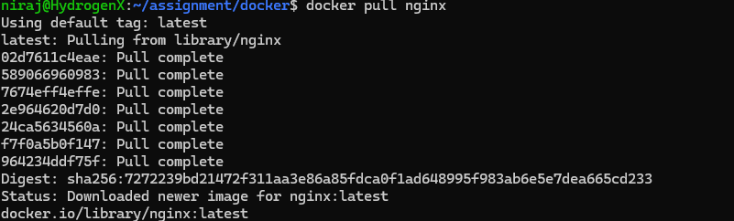
- Run it in a container.
- Map container port 80 to host port 8080.
- Open the browser and check if Nginx default page is visible.
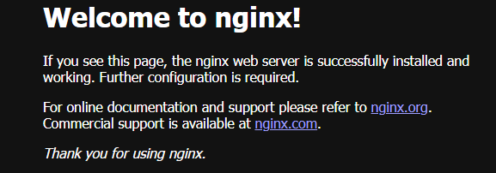
Q2. Run a Python App inside a Container
- Use the official python:3.10-slim image.
- Run a container that executes a one-line Python program printing "Hello Docker".
- Observe what happens after execution.

Q3. Run a MySQL Database
- Start a mysql:8 container with:
  - Root password set via environment variable.
  - A new database created at startup.
- Access the container shell.
- Connect to MySQL inside and verify the database exists.
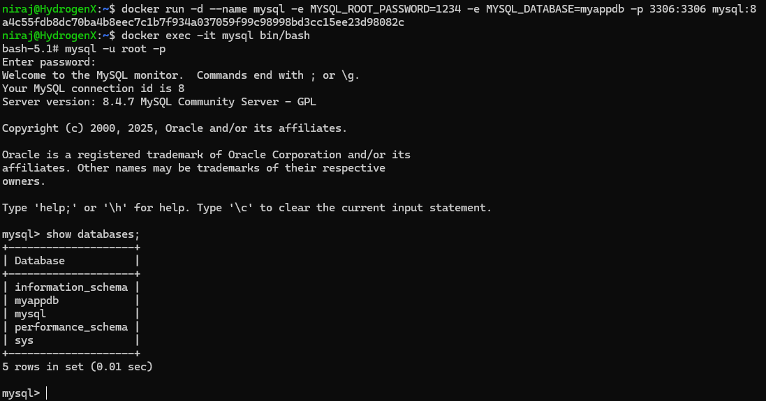

2. Custom Images – Build Your Own
Q4. Build a Flask Application Image
- Write a small Flask app that returns "Hello from Flask in Docker".
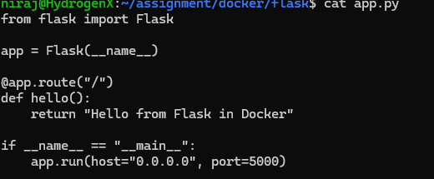

- Create a requirements.txt file and Dockerfile.
- Build your own image.
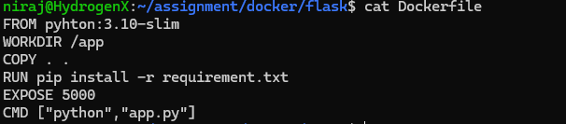
- Run the container and check the response in a browser.
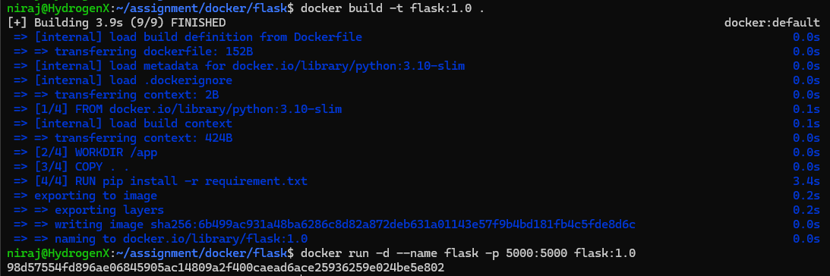

Q5. Create a Custom Nginx Image
- Create a simple index.html file with your name.
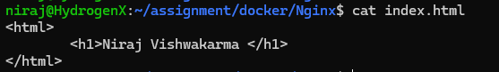
- Use nginx:alpine as base image.
- Copy your HTML file into the container.
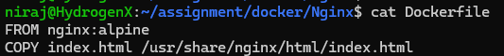

- Build and run the custom image.
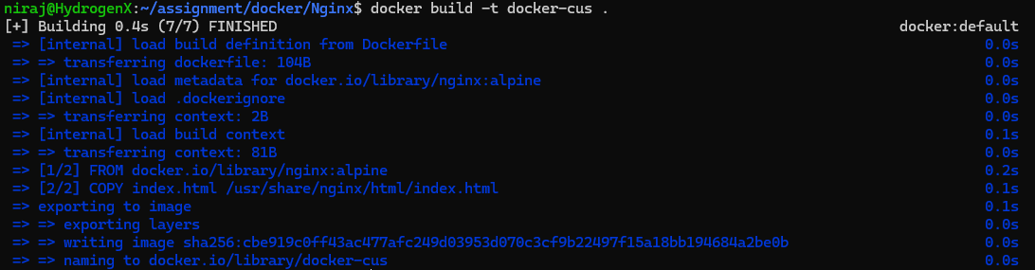
- Open in browser to confirm your page loads.


3. Volumes – Persisting Data
Q6. WordPress with Persistent MySQL
- Run a mysql:8 container with a named volume for /var/lib/mysql.
- Run a wordpress container connected to the database.
- Stop and remove the containers. 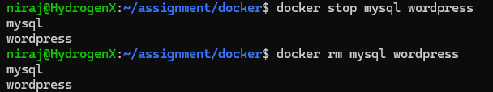
- Restart them and confirm WordPress still remembers your data.
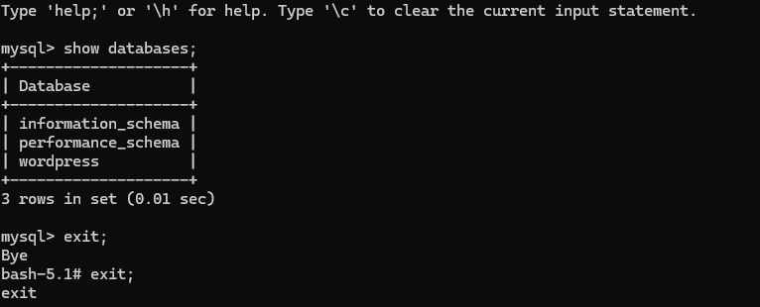
Q7. Flask with Bind Mount
- Create or modify your Flask app locally.
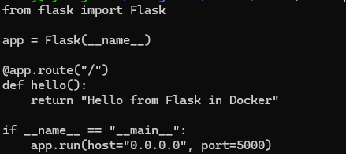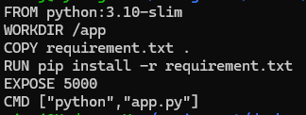
- Run the app container with a bind mount mapping your project folder.
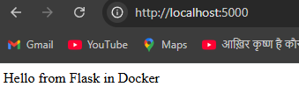

- Edit code on the host machine.
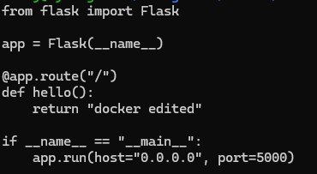
- Check if changes reflect without rebuilding the image.
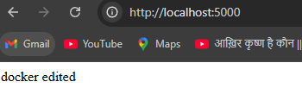

4. Networks – Multi-Container Applications
Q8. Flask + Redis Counter App
- Write a Flask app that connects to Redis to store a counter.
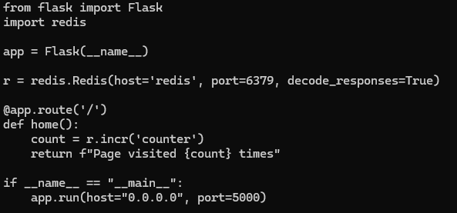
- Create a user-defined Docker network.

- Run a Redis container in the network.
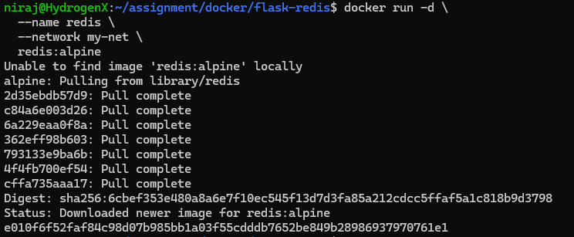
- Run your Flask container in the same network.
- Refresh the app page multiple times and confirm the counter increments.

Q9. MySQL + WordPress Blogging App
- Create a custom Docker network.
- Run a MySQL container with environment variables for root password and database.
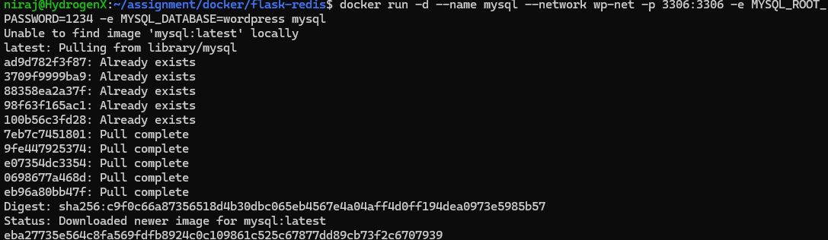

- Run a WordPress container connected to the same network.
- Complete WordPress setup in the browser.
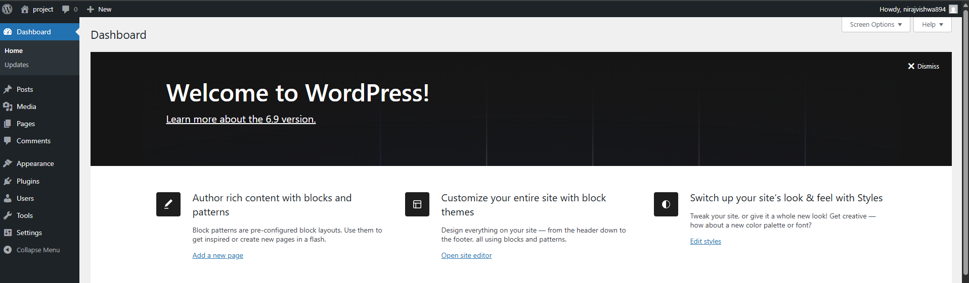

Docker Compose
Q10. Convert Flask + Redis App into Docker Compose
- Write a docker-compose.yml file to define Flask and Redis services.
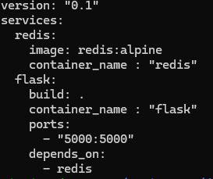
- Bring up the stack using docker-compose up.
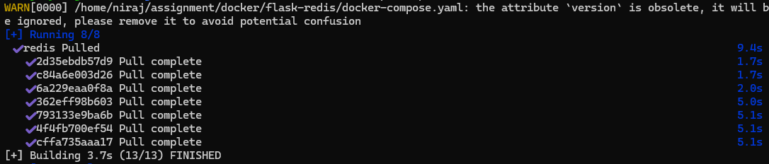

- Verify application works as expected.

Q11. Node.js + MongoDB Full Stack Setup
- Write a simple Node.js app that saves data to MongoDB.
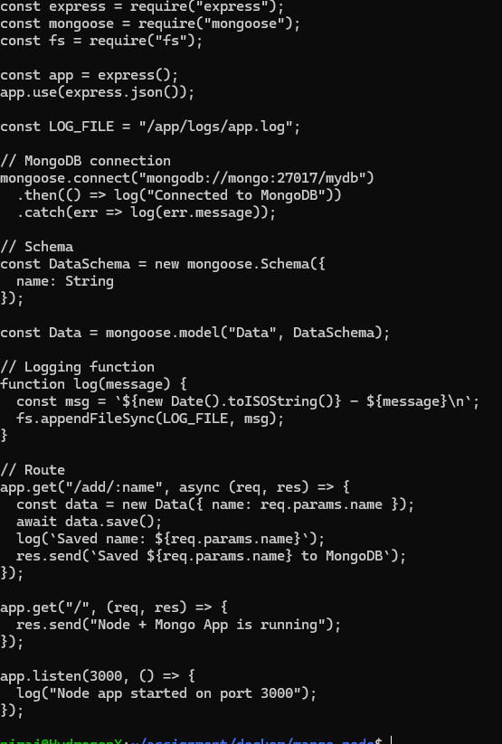

- Create a custom image for the Node.js app.
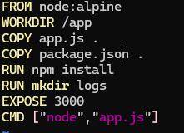
- Store application logs in a volume.
- Connect Node.js and MongoDB containers via a custom network.
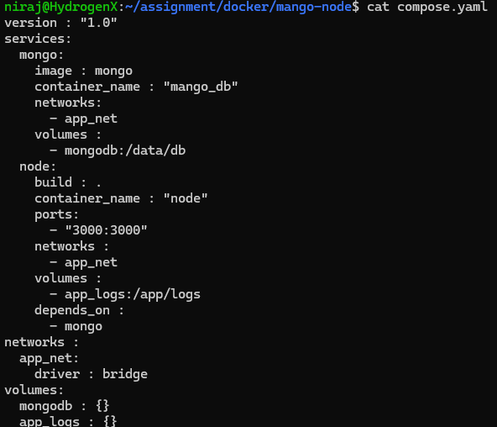
- Test end-to-end data flow.
